CSE520
Samuel Marrujo
Professor Yu
Lab 16
Use the program and to create a prism

In this lab, we are to use the program given and create a prism. I have completed the task:

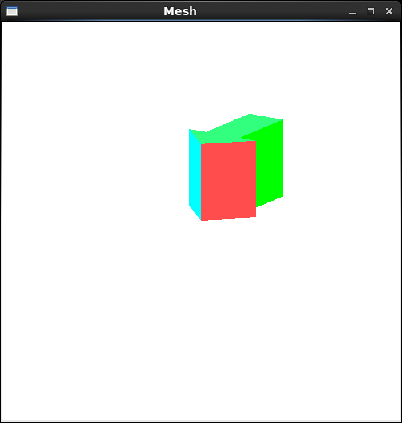
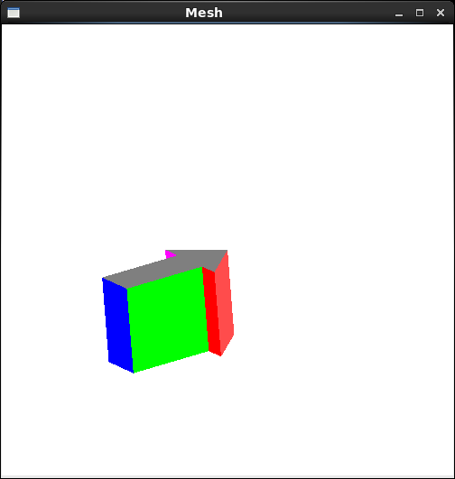
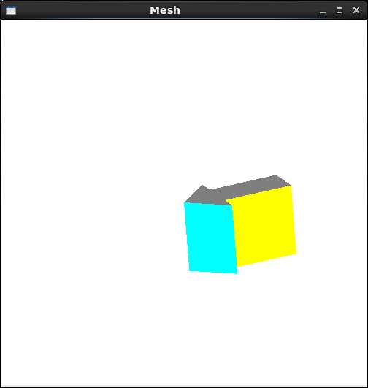
Code:
//Mesh.cpp : Mesh class member functions

#include "Mesh.h"
#include <iostream>

using namespace std;

Mesh::Mesh()
{
nVertices = nNormals = nFaces = 0;
}

//Read mesh data from file
bool Mesh::readData ( char fName[] )
{
fstream ins;
ins.open ( fName, ios::in );
cout << "opening file " << fName << endl;
if( ins.fail() ) return false; // error - can't open file
if( ins.eof() ) return false; // error - empty file
ins >> nVertices >> nNormals >> nFaces; // read in number of vertices, normals, and faces
for ( int i = 0; i < nVertices; i++ ) { //read vertices
Point3 p;
ins >> p.x >> p.y >> p.z;
vertexList.push_back ( p );
}
for ( int i = 0; i < nNormals; i++ ) { //read normals
Vector3 v;
ins >> v.x >> v.y >> v.z;
normalList.push_back ( v );
}
cout << endl;
for ( int i = 0; i < nFaces; i++ ) {
Polygon p;

ins >> p.n;
for ( int j = 0; j < p.n; j++ ) {
int vertexIndex;
ins >> vertexIndex;
p.vertices.push_back ( vertexIndex );
}
for ( int j = 0; j < p.n; j++ ) {
int normalIndex;
ins >> normalIndex;
p.normals.push_back ( normalIndex );
}
faceList.push_back ( p );
}

return true;
}

//render the mesh
void Mesh::renderMesh()
{
//Draw each polygon of the mesh

glEnable( GL_CULL_FACE );
glCullFace ( GL_BACK ); //do not render back faces

//draw one polygon at a time
for ( int i = 0; i < nFaces; i++ ) {
setColor ( i );
glBegin ( GL_POLYGON );
//specifying vertices of the polygon
for ( int j = 0; j < faceList[i].n; j++ ) {
int vi = faceList[i].vertices[j]; //vertex index
int ni = faceList[i].normals[j]; //normal index
glNormal3f ( normalList[ni].x, normalList[ni].y, normalList[ni].z );
glVertex3f ( vertexList[vi].x, vertexList[vi].y, vertexList[vi].z );
} //for j
glEnd();
} //for i
}

void Mesh::setColor( int n )
{

if (n == 1)
glColor3f(1, 0, 0);
else if (n == 2)
glColor3f(0, 1, 0);
else if (n == 3)
glColor3f(0, 0, 1);
else if (n == 4)
glColor3f(1, 1, 0);
else if (n == 5)
glColor3f(1, 0, 1);
else if (n == 6)
glColor3f(0, 1, 1);
else if (n == 7)
glColor3f(0.5, 0.5, 0.5);
else if (n == 8)
glColor3f(0.2, 1, 0.5);
else if (n == 0)
glColor3f(1.0, 0.3, 0.3);
else
cout << "too many faces";
}

Prism.txt Code:
14 9 9
0 0 0 1 1 0 0.5 1 0 0.5 3 0 -0.5 3 0 -0.5 1 0 -1 1 0
0 0 2 1 1 2 0.5 1 2 0.5 3 2 -0.5 3 2 -0.5 1 2 -1 1 2

0.707 -0.707 0 0 1 0 1 0 0 0 1 0 0 -1 0 0 1 0 -0.707 -0.707 0
0 0 1 0 0 -1

4 0 1 8 7 0 0 0 0
4 1 2 9 8 1 1 1 1
4 2 3 10 9 2 2 2 2
4 3 4 11 10 3 3 3 3
4 4 5 12 11 4 4 4 4
4 5 6 13 12 5 5 5 5
4 6 0 7 13 6 6 6 6
7 0 6 5 4 3 2 1 7 7 7 7 7 7 7
7 7 8 9 10 11 12 13 8 8 8 8 8 8 8

